**DBMS Case Studies**

**DBMS Case Study: Library Management System Assignment Overview**

You are tasked with designing a database for a **Library Management System**. The system must efficiently handle operations such as book lending, membership management, and inventory tracking.

**Assignment Instructions  
1. Requirements of the System**

The system should:

 Manage information about books, including titles, authors, genres, and availability.

 Track library members, including their personal details and borrowing history.

 Record loan transactions, including the issue date, return date, and fines (if applicable).

 Support librarian operations, such as adding or removing books and managing member accounts.

 Generate reports on overdue books and popular titles.  
**Deliverable:** Create a document listing the system requirements in bullet points.

**2. Identify at Least 5 Entities**

Based on the requirements, define the following entities:  **Book**

Attributes: Book_ID, Title, Author, Genre, ISBN, Availability.  **Member**

Attributes: Member_ID, Name, Address, Phone, Membership_Date.

1 **Loan**Attributes: Loan_ID, Book_ID, Member_ID, Issue_Date, Return_Date, Fine.

 **Librarian**Attributes: Librarian_ID, Name, Email, Phone.

 **Publisher**Attributes: Publisher_ID, Name, Address, Contact.

**Deliverable:** Document a table with the names of entities and their attributes. **3. Design the ER Diagram**

**Instructions to Use StarUML Software:**

 **Create a New Project:**Open StarUML and create a new project.  
Choose the **Entity-Relationship Diagram** template.

 **Add Entities and Attributes:**Create entities for **Book**, **Member**, **Loan**, **Librarian**, and **Publisher**. Add attributes to each entity as listed above.

 **Define Relationships:**Establish the following relationships:

A **Book** can be issued to multiple **Members** (many-to-many). A **Member** can borrow multiple books (many-to-many).  
A **Loan** links **Books** and **Members** (associative entity).  
A **Book** can have one or more **Publishers** (one-to-many).

A **Librarian** manages multiple **Loans** (one-to-many).  **Draw Cardinalities:**

Use the proper notations (e.g., 1N, NM to represent cardinalities.  **Export the Diagram:**

Once complete, export the diagram as a PNG or PDF file.

**Deliverable:** Submit the ER diagram with clear relationships, attributes, and cardinalities.

**4. Submission Guidelines**

Submit the following materials to your subject faculty:  **Document:**

System requirements.

List of entities and their attributes.  **Links:**

Share the StarUML project file or a link to download it.  **Screenshots:**

Screenshots of the StarUML interface showing your diagram and its components.

 **Exported Diagram:**Share the final ER diagram as a PNG or PDF.

**Objective**

This assignment ensures that you:  
 Understand the process of requirement gathering for database systems.  Develop skills to design and represent databases using ER diagrams.  
 Practice presenting your work in a structured and professional manner.

Answers:-

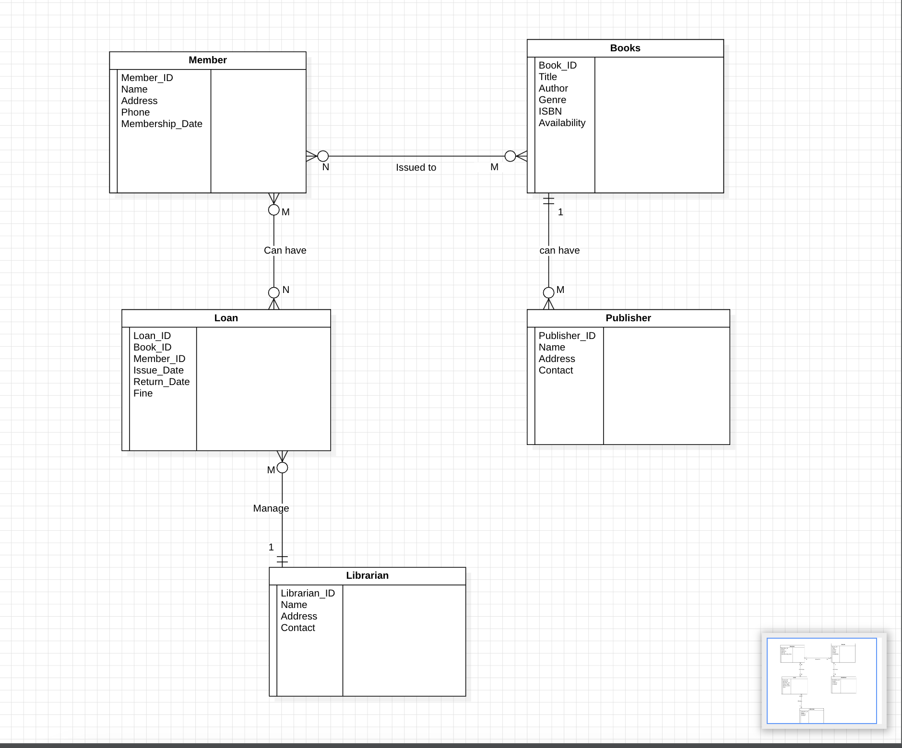

**ER Diagram for Library Management System :**

**An Entity can be any person, place, object.**

Entity 1 : Book -

* Book_ID: An unique identifier number for each book.
* Title : Title of the book.
* Author : Name of the author of the book.
* Genre : Genre of the book.
* ISBN : ISBN of the book.
* Availability : Is book available or not .

Entity 2 : Member -

* Member_ID : Unique identifier number of member.
* Name : Name of the member.
* Address : Residential address of the member.
* Phone : Contact number of member
* Membership_Date : Date when member joined.

Entity 3 : Loan -

* Loan_ID : An unique identifier number to track user details and book details or to track loan transaction.
* Book_ID : unique number to identify book.
* Issue_Date : date when member took loan or borrowed book.
* Return_Date : date when member returned book.
* Fine : amount when member dont submit the book on time.

Entity 4 : Librarian -

* Librarian_ID : Unique identifier number of librarian.
* Name : Name of the librarian.
* Email : email of librarian.
* Phone : phone number of librarian.

Entity 5 : Publisher -

* Publisher_ID : Unique identifier number of publisher.
* Name : name of the publisher.
* Address : residential address of publisher.
* Contact : contact details of publisher.